**Database Schema and Mapping:**

* Designed a relational database schema for a university system with tables for students, courses, departments, and grades.
* Established relationships between entities: Student, Department, Course, and Student_Course.
* Utilized foreign keys to maintain referential integrity, linking Student and Course tables to the Department table.
* Enforced data consistency through proper normalization of the schema.

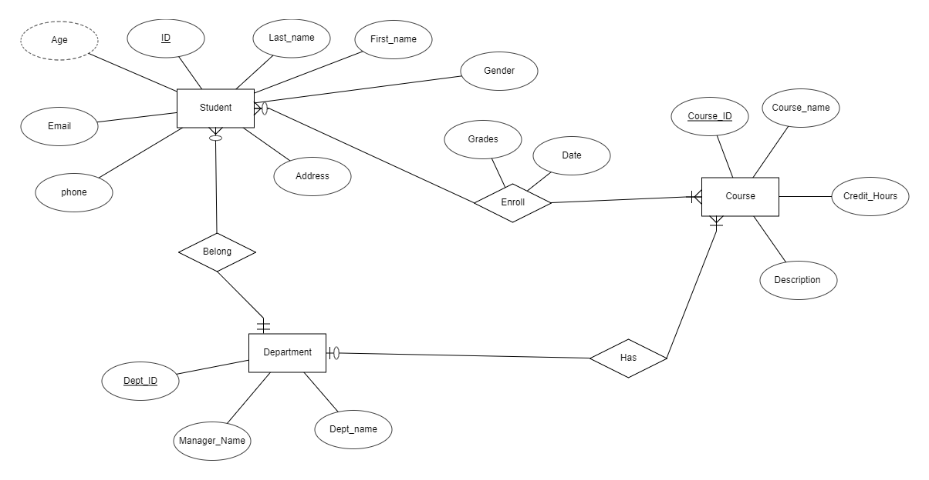

|  |  |  |  |  |  |  |  |  |
| --- | --- | --- | --- | --- | --- | --- | --- | --- |
| Student | Student_id | first_name | Last_name | address | email | Gender | phone | Dept_id(fK) |
| Department | Dept_id | Dept_name | Manager_name |
| course | Course_id | Course_name | description | Credit_hours | Dept_id(fK) |
| Student_course | Student_id | Course_id | date | grades |

**SQL Script:**

1. **DEPARTMENT Table:**
   * Created a DEPARTMENT table with attributes DEPT_ID, DEPT_NAME, and MANAGER_NAME.
   * Defined DEPT_ID as the primary key to ensure uniqueness.
2. **COURSE Table:**
   * Established a COURSE table containing attributes COURSE_ID, COURSE_NAME, DESCRIPTION, CREDIT_HOURS, and DEPT_ID.
   * Set COURSE_ID as the primary key and DEPT_ID as a foreign key referencing DEPARTMENT.
3. **STUDENT Table:**
   * Developed a STUDENT table with attributes STUDENT_ID, FIRST_NAME, LAST_NAME, GENDER, ADDRESS, EMAIL, PHONE, and DEPT_ID.
   * Specified STUDENT_ID as the primary key and DEPT_ID as a foreign key referencing DEPARTMENT.
4. **STUDENT_COURSE Table:**
   * Designed a STUDENT_COURSE table with attributes GRADES, STUDENT_ID, COURSE_ID, and DATE_G.
   * Established a composite primary key using STUDENT_ID, COURSE_ID, and DATE_G.
   * Defined foreign keys for STUDENT_ID and COURSE_ID referencing STUDENT and COURSE tables.

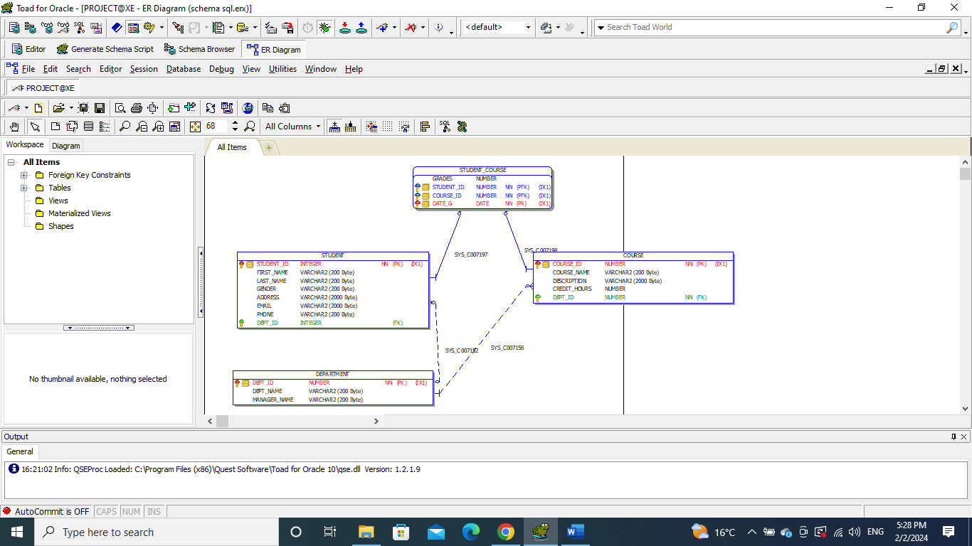

CREATE TABLE DEPARTMENT

(

DEPT_ID NUMBER NOT NULL,

DEPT_NAME VARCHAR2(200 BYTE),

MANAGER_NAME VARCHAR2(200 BYTE),

PRIMARY KEY (DEPT_ID)

);

CREATE TABLE COURSE

(

COURSE_ID NUMBER NOT NULL,

COURSE_NAME VARCHAR2(200 BYTE),

DESCRIPTION VARCHAR2(2000 BYTE),

CREDIT_HOURS NUMBER,

DEPT_ID NUMBER NOT NULL,

PRIMARY KEY (COURSE_ID),

FOREIGN KEY (DEPT_ID) REFERENCES DEPARTMENT (DEPT_ID)

);

CREATE TABLE STUDENT

(

STUDENT_ID INTEGER NOT NULL,

FIRST_NAME VARCHAR2(200 BYTE),

LAST_NAME VARCHAR2(200 BYTE),

GENDER VARCHAR2(200 BYTE),

ADDRESS VARCHAR2(2000 BYTE),

EMAIL VARCHAR2(2000 BYTE),

PHONE VARCHAR2(200 BYTE),

DEPT_ID INTEGER,

PRIMARY KEY (STUDENT_ID),

FOREIGN KEY (DEPT_ID) REFERENCES DEPARTMENT (DEPT_ID)

);

CREATE TABLE STUDENT_COURSE

(

GRADES NUMBER,

STUDENT_ID NUMBER NOT NULL,

COURSE_ID NUMBER NOT NULL,

DATE_G DATE,

PRIMARY KEY (STUDENT_ID, COURSE_ID, DATE_G),

FOREIGN KEY (STUDENT_ID) REFERENCES STUDENT (STUDENT_ID),

FOREIGN KEY (COURSE_ID) REFERENCES COURSE (COURSE_ID)

);

**PLSQL Procedure and Function:**

1. **PLSQL Procedure (PROJECT.update_info):**
   * Developed a procedure for updating student information, taking parameters for student details (ID, name, gender, address, email, phone, department).
   * Utilized an UPDATE statement to modify the corresponding student record in the STUDENT table.
2. **PLSQL Function (PROJECT.calc_gpa):**
   * Implemented a function to calculate GPA based on the provided student ID.
   * Utilized a SELECT statement with JOINs and aggregation to calculate grade points and total credit hours.
   * Employed conditional logic to determine the GPA range and return the corresponding letter grade ('A', 'B', 'C', or 'F').

**Procedure :**

CREATE OR REPLACE procedure PROJECT.update_info ( v_student_id int , v_first_name varchar2,v_last_name varchar2,v_gender varchar2 , v_address varchar2 , v_email varchar2 , v_phone varchar2 , v_dept_id number )

is

begin

UPDATE Student

SET

first_name =v_first_name,

last_name=v_last_name,

gender=v_gender,

address=v_address,

email=v_email,

phone=v_phone,

dept_id=v_dept_id

WHERE student_id = v_student_id;

end;

/

**Function :**

CREATE OR REPLACE function PROJECT.calc_gpa (v_student_id number )

return varchar2

is

v_credit_hours number;

v_gpa number;

v_grade_points number;

begin

select sum (c.credit_hours * sc.grades) as grade_points ,

sum(credit_hours) as total_credit_hours

into v_grade_points , v_credit_hours

from course c

join student_course sc

on c.course_id = sc.course_id

where sc.student_id = v_student_id

group by sc.student_id ;

v_gpa := v_grade_points / v_credit_hours ;

IF v_gpa between 3.5 and 4 THEN

RETURN 'A';

ELSIF v_gpa between 2.5 and 3.5 THEN

RETURN 'B';

ELSIF v_gpa between 1.5 and 2.5 THEN

RETURN 'C';

ELSE

RETURN 'F';

END IF;

end;

/

**So as conclusion :**

* Established a robust relational database schema with tables designed to handle student, course, department, and grading information.
* Implemented SQL scripts to create tables with appropriate primary and foreign key relationships.
* Developed a PLSQL procedure to update student information and a function to calculate GPA.
* Ensured referential integrity by enforcing foreign key relationships between tables.
* Documented each component for clarity and ease of understanding in the context of the university data management system.

**Bash Scripts for Automation:**

1. **Disk Space Monitoring Script:**
   * Created a Bash script for monitoring disk space using **df** and **awk**.
   * Implemented conditional checks to send alerts when disk space exceeds a predefined threshold.

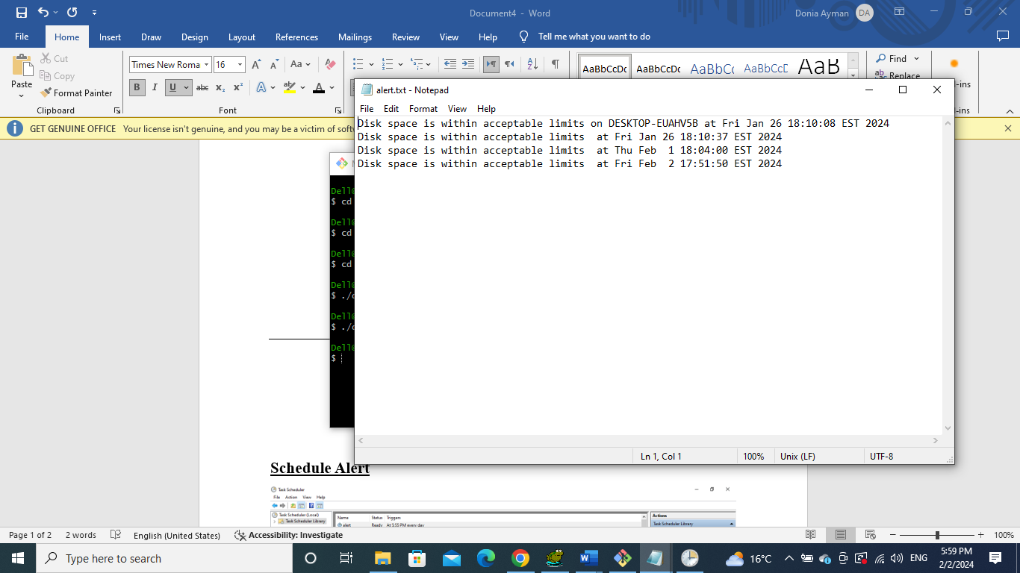

1. **Scheduled Anomaly Checking Script:**
   * Utilized Windows Task Scheduler to schedule the anomaly checking script.
   * Configured a scheduled task for regular execution at specified intervals.

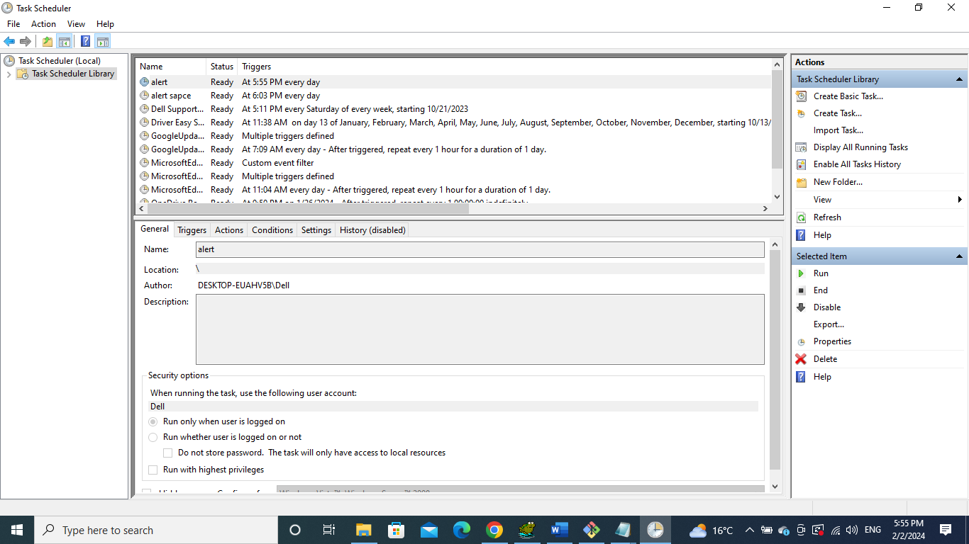

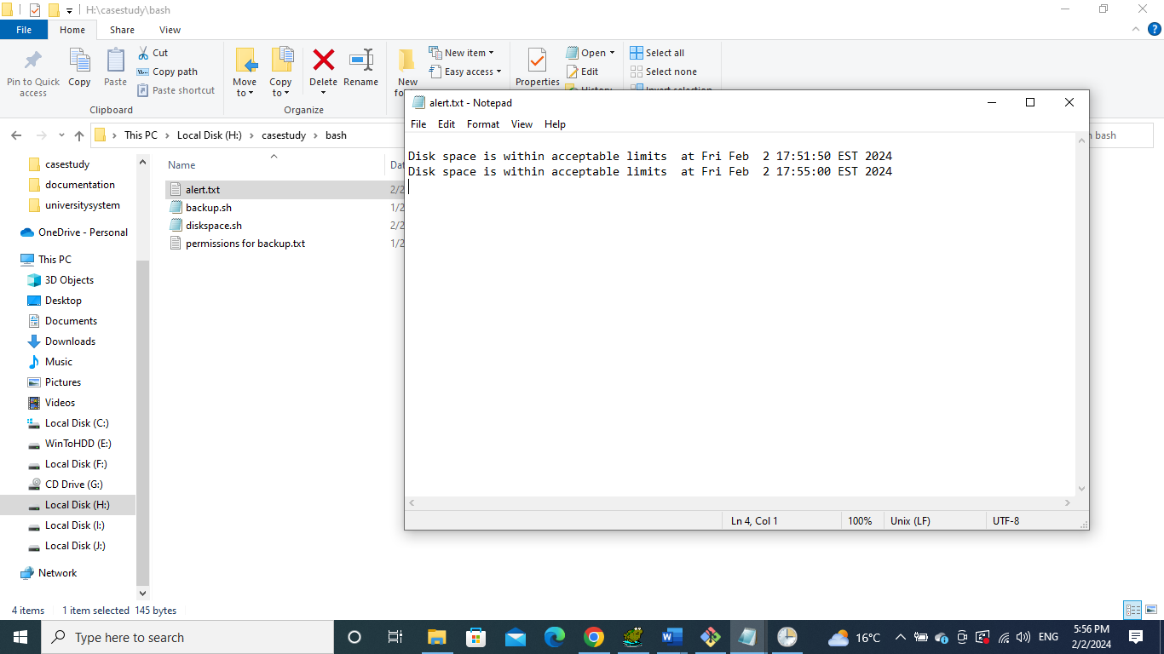

1. **Oracle Database Backup Script:**
   * Designed a Bash script for Oracle database backup with **exe**.
   * Ensured backup file uniqueness with a timestamp.
   * Give permission from sys to can backup   
     GRANT READ, WRITE ON DIRECTORY DATA_PUMP_DIR TO project;

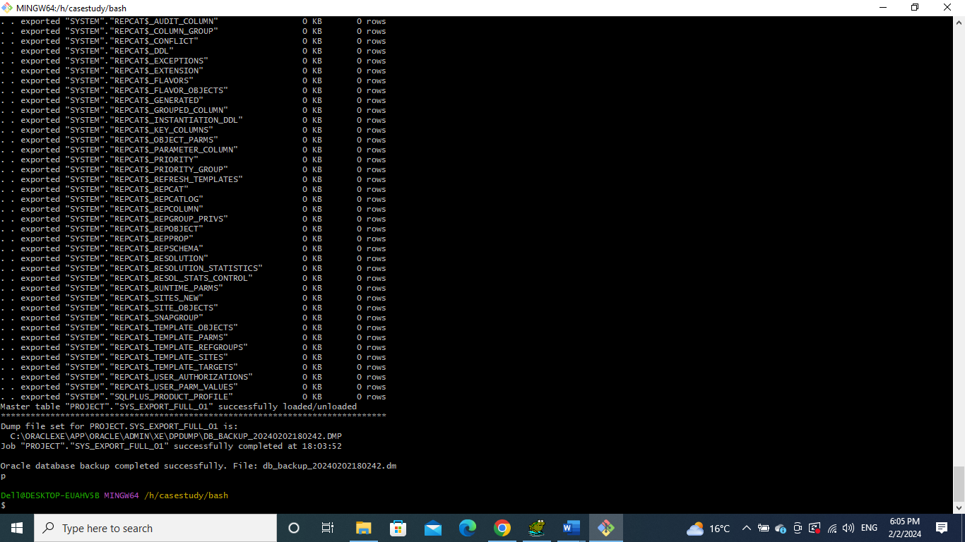

**Java Application :**

1. **Student Management:**
   * Implemented methods for adding, updating, and deleting students.
   * Maintained a TableView for displaying student information.
   * Validated input, checked for duplicates.
2. **Course Management:**
   * Incorporated functionality for adding, updating, and deleting courses.
   * Ensured data integrity through SQL queries and user interactions.
3. **Department Management:**
   * Developed methods for department-related operations.
   * Executed SQL queries for adding, updating, and deleting departments.
4. **Grades Management:**
   * Established procedure for managing student grades.
   * Utilized SQL queries to handle grade-related functionalities.
5. **Reports:**
   * Implemented a detailed student report generation.
     + Executed complex SQL queries with JOIN operations.
     + Fetched and displayed data in a TableView.
     + Obtained GPA information using a PLSQL function.
   * Designed a department-wise report generation.
     + Utilized SQL queries with LEFT JOIN operations.
     + Populated a TableView with department-specific data.

